**Learnify**

Learnify is a productivity app designed for students and teachers to help them better organize their time and priorities. The app was made in Unity Engine and Android Studio. We also used Adobe Photoshop and Adobe Illustrator for specific design elements.

You may wonder what the app does. Well, it keeps track of all your exams and homework and it gives you notifications when an exam is coming. The app consists of 2 separate tabs, each representing a cronologically ordered list of the exams and homework, respectively. In the down left corner of the screen you can find a “+” (plus) button, used to add an exam/homework to the list, depending on which tab you have selected.

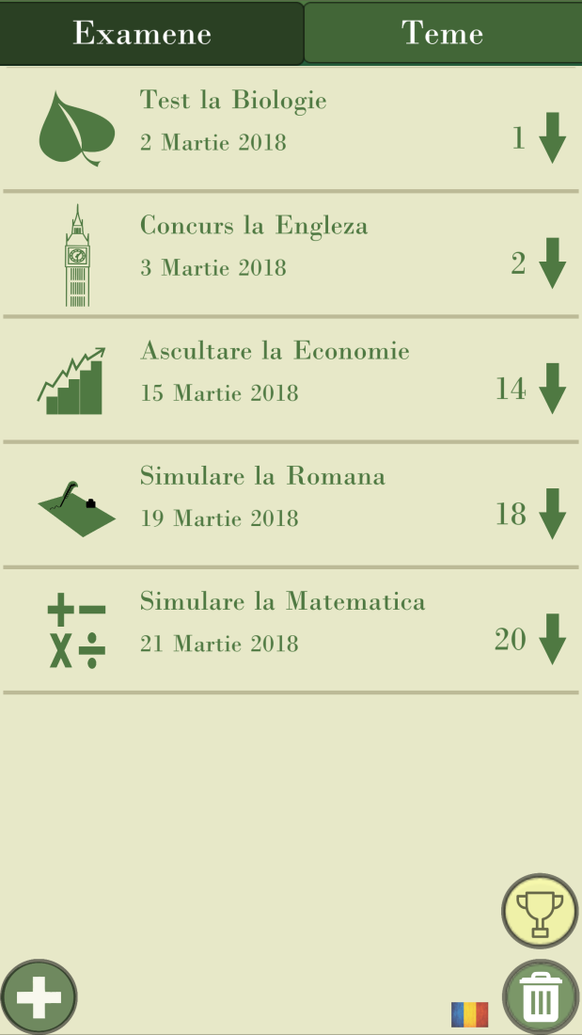

Upon pressing it, you will be shown a menu where you can either choose the type of the exam (e.g.: test paper, olympiad, simulation, etc.) or add the details of the homework (e.g.: page 6, exercises 2, 5, 8) and, regardless of what tab you have chosen, the subject for which you have the event (e.g.: Chemistry, Philosophy, English etc.) and the date (e.g.: 23 May 2018).

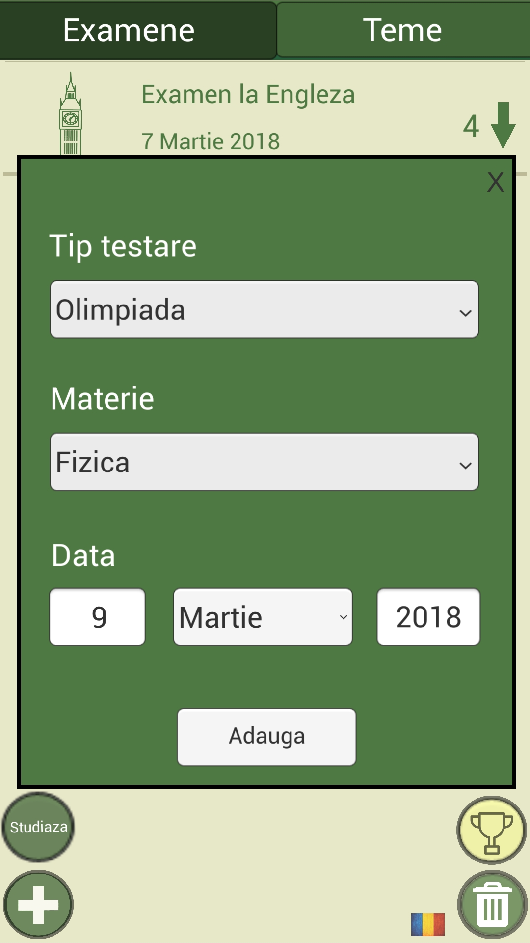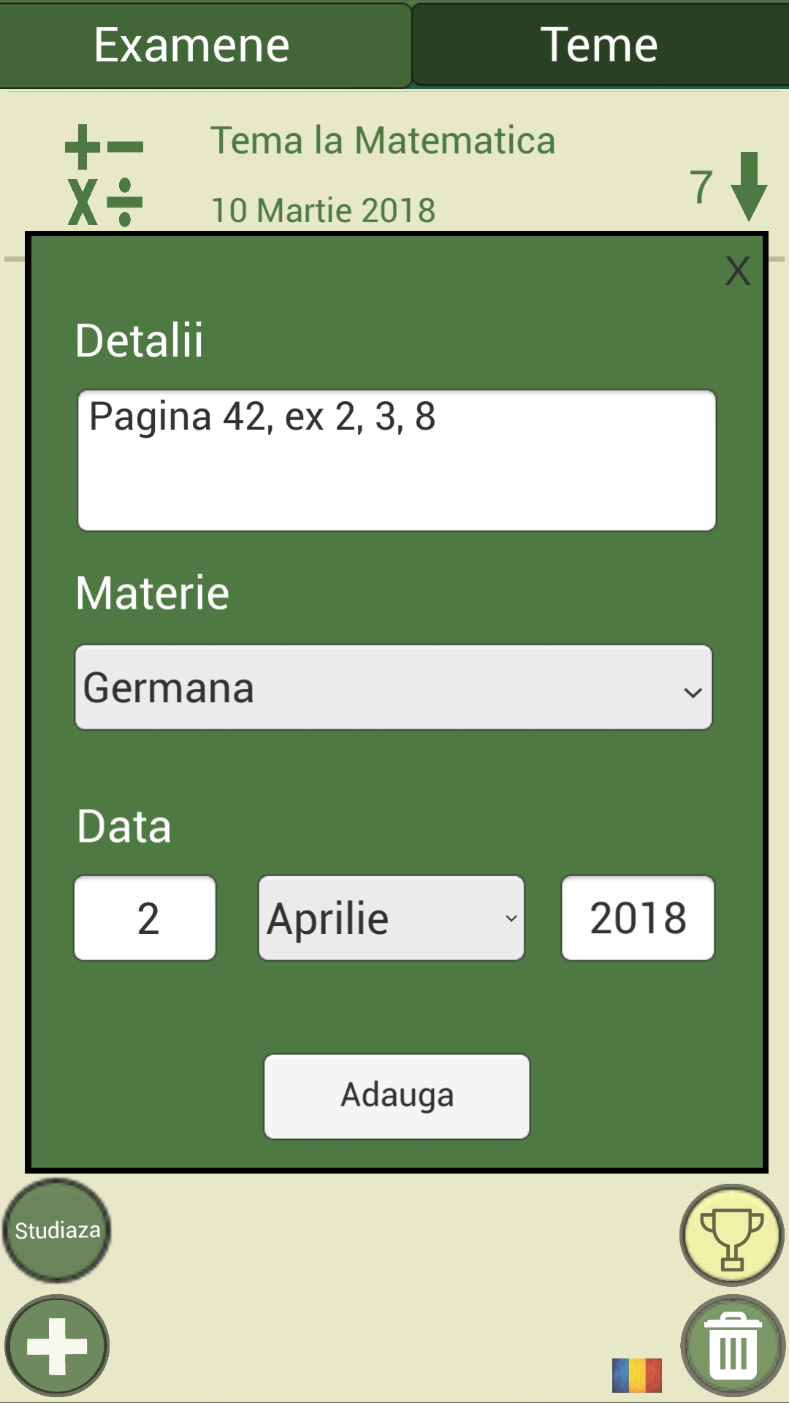

Upon pressing the Add button, the event will be added to the respective list, displaying a title (e.g.: Test at French, Homework at Physics etc.), the date, a unique, suggestive icon, depending on the subject you have chosen (e.g.: for Biology there will be displayed a leaf, for Physics an atom, for English the Big Ben, etc.) and a countdown of the remaining days. The atractive GUI helps the users differentiate more easily the subjects and events.

You can also press on a homework to see its details.

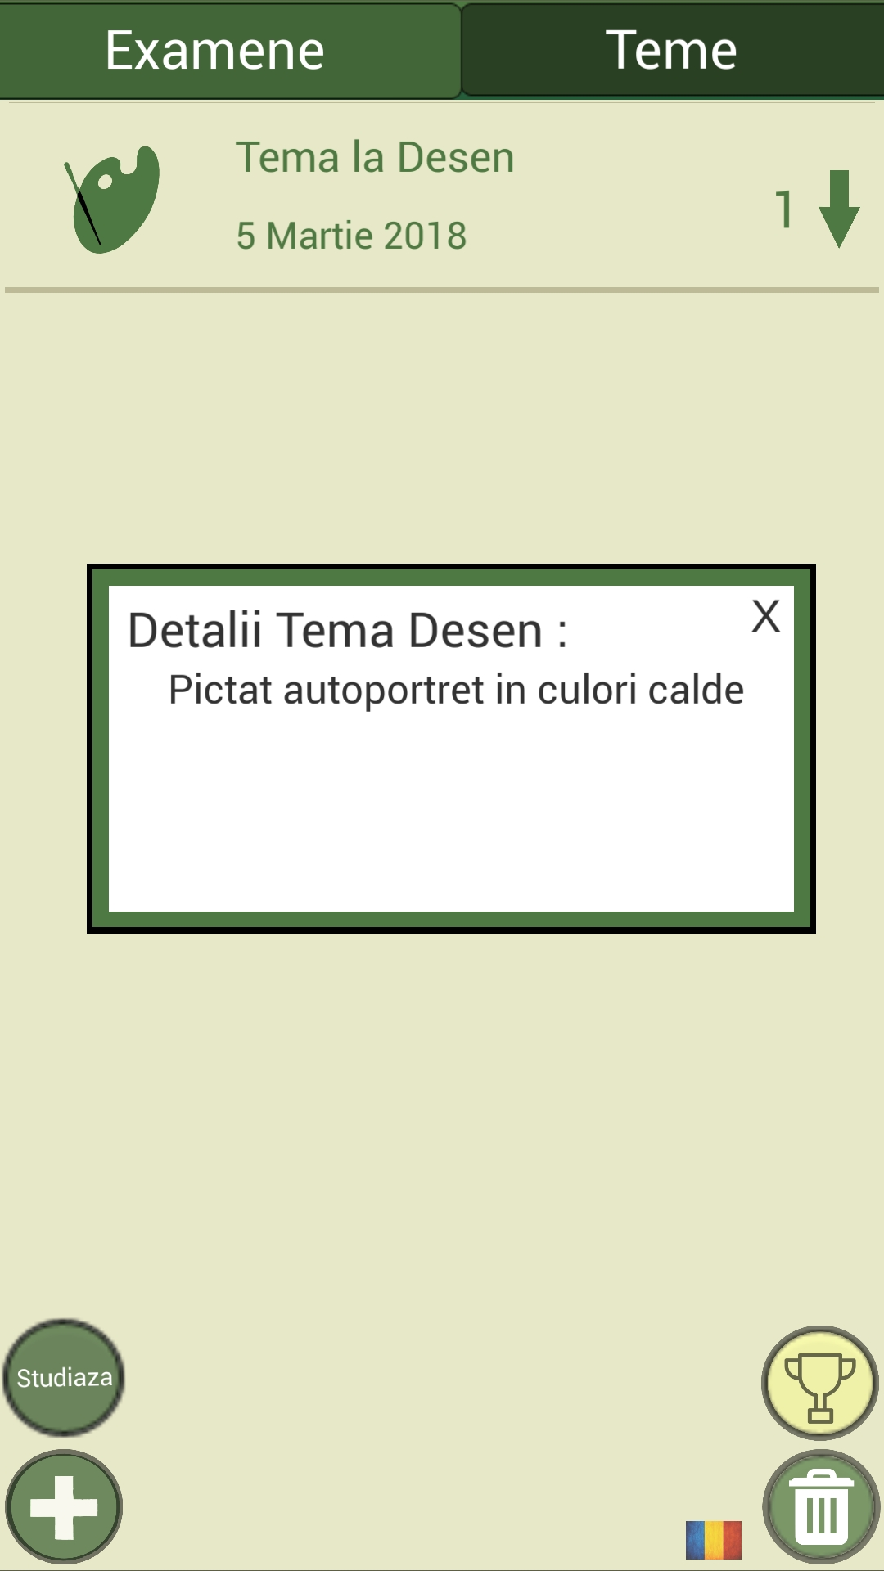

In the down right corner of the screen you can find the Trash Can button, used to delete exams and homework (an event will autodelete itself if its date has already passed). If you press the Delete button once, you will enter the delete mode, where you can press any event to have it erased. While in delete mode, if you press the Trash Can button again, you will exit delete mode.

The Achievements button is found above the Delete button. It has a trophy icon and is used to access the achievements, both the locked and unlocked ones.

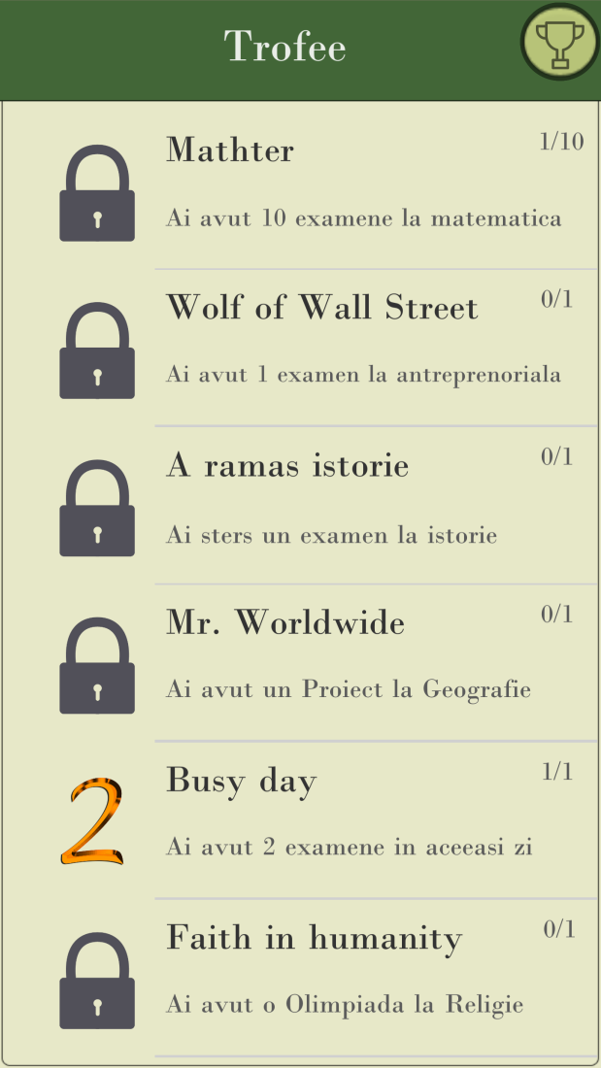

To the left of the Delete button, you can find the Language button, used to switch between Romanian and English (we plan to add support for several other languages in the near future) in the app.

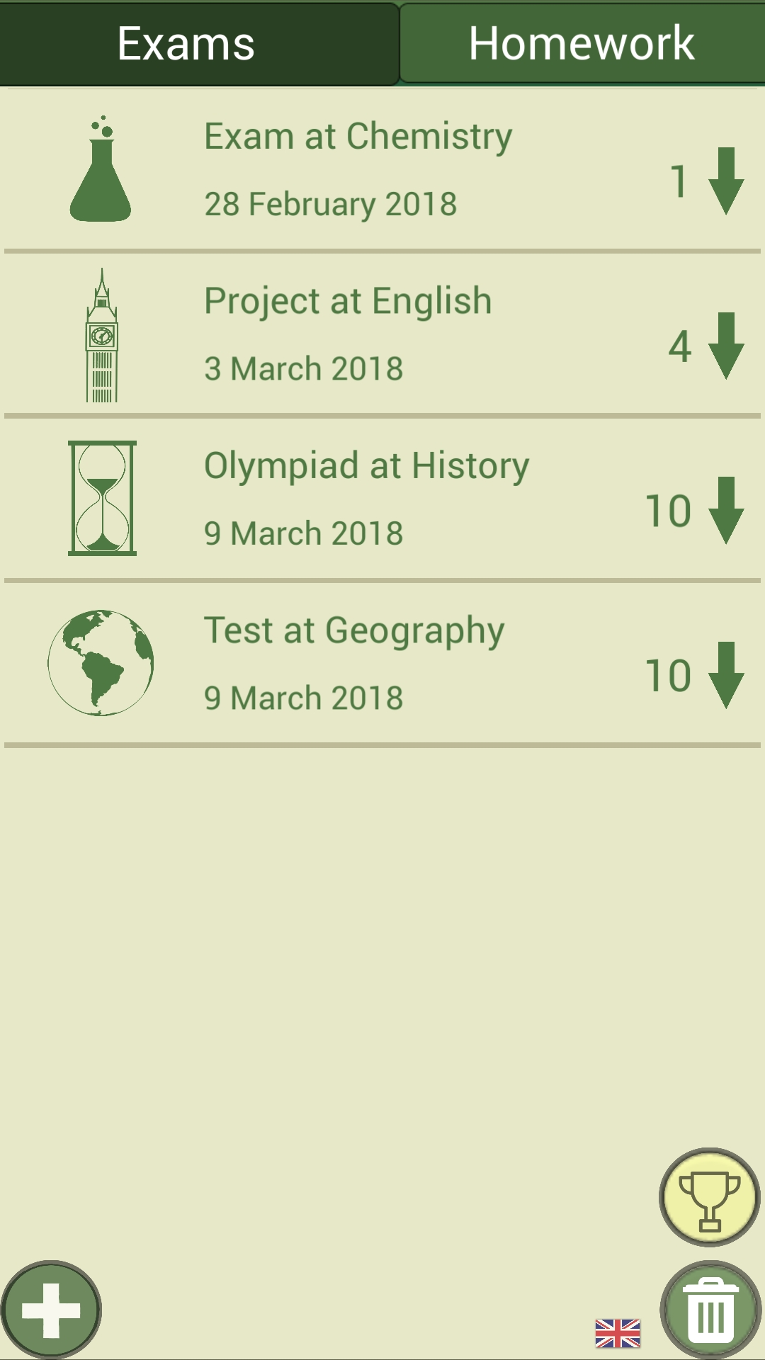

The app also sends you notifications when an exam is approaching, with a week, two days, one day, and zero days prior to its arrival.

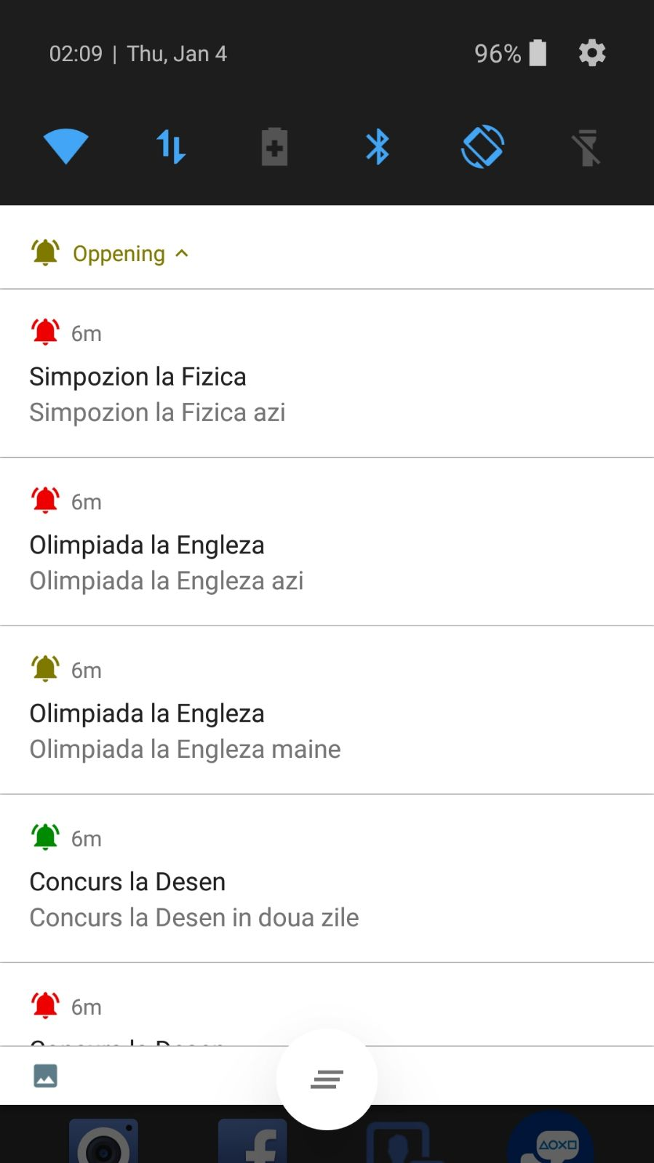

We know that the phone is often an impediment when we need to learn. In this regard, we have created an option that blocks the phone in the app for a previously set time so that we can not waste time on social networks or different games.

Thus, the study button, located above the plus button, is used to enter the time interval in which you want to learn (eg 2 hours, 3.5 hours, etc.).

This study mode can be activated until midnight, sleep deprivation being a factor extremely harmful to human health.

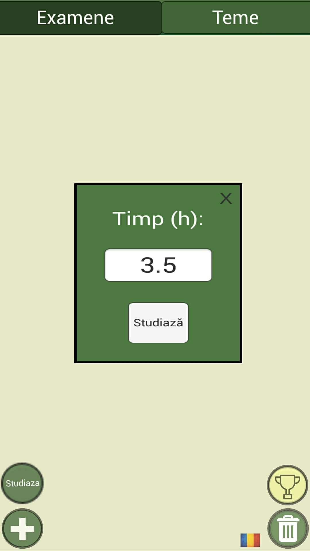

Once the study interval is set, the back and the recent buttons are blocked. If you still try to quit the application, the phone will reopen it, in order to prevent access to other applications that can distract you from the studying.

Also, the phone will be set to vibrate as you learn to avoid deconcentration due to notifications.

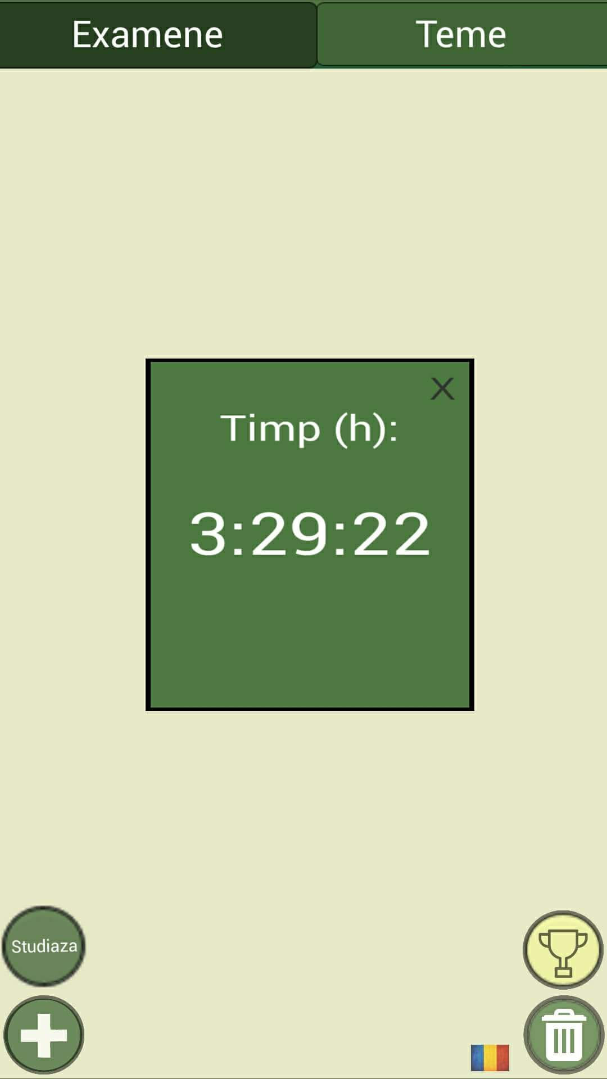

Impediments

Being two perfectionists, we have always tried to solve all the bugs that appeared. The god of IT decided to bless us with a multitude of problems, more or less major, which we have always managed to solve. Here are some examples:

* Once an exam was deleted, notifications for it were stll sending
* Users could add events on dates that had already passed
* Certain texts did not translate when you changed the language
* If you were trying to exit the application while the study mode was active, the application was crashing

We also encountered problems with the different pictograms that did not match the rest of the design or which did not represent the essence of the subject, as well as the logo, which had to go through 12 iterations until the final version.

The design has also been a tricky element. We have tried many variants before deciding on this classic, old style design.

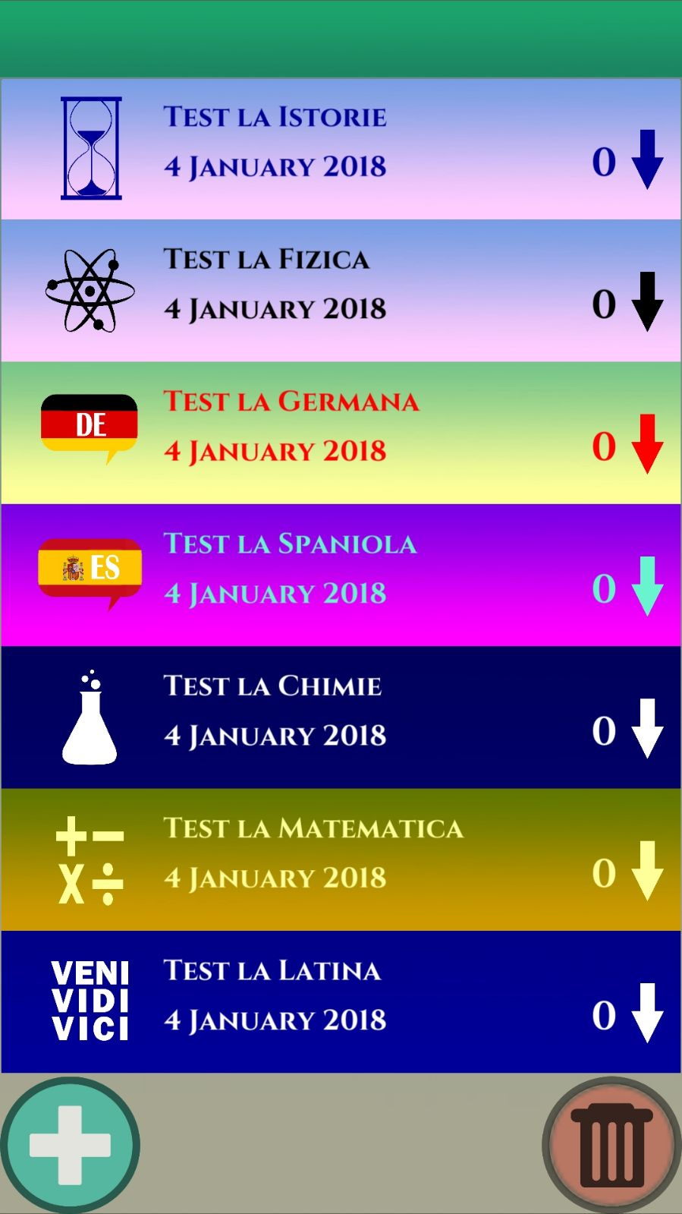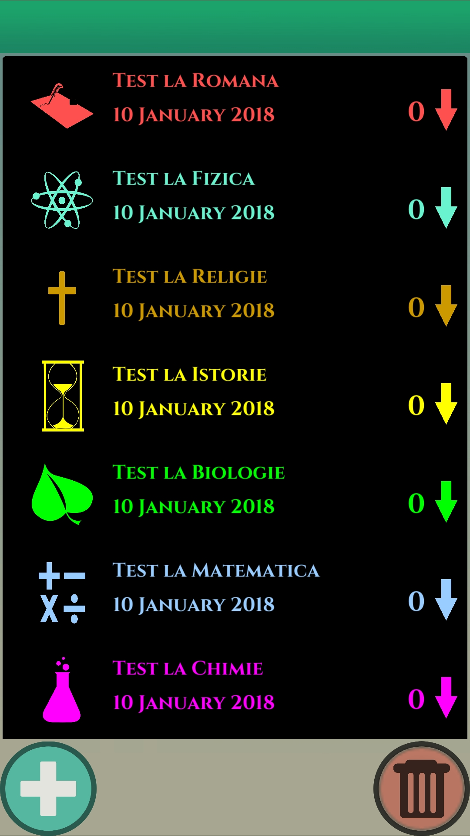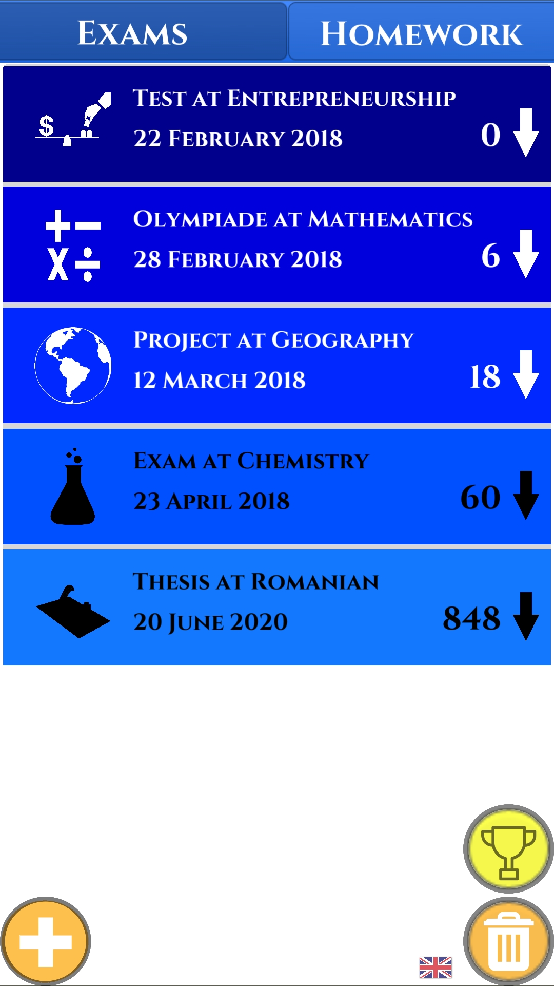

Next steps:

* To add more achievements
* To add support for more languages
* To improve the study more and shorten the time for re-entering the application
* To make the application viable for teachers as well. When you open it for the first time, it will ask you if you are a student or a teacher. If you are a teacher, you will have to write in the subject you teach. Then, when you add an event as a teacher, it will automatically be added to your subject; instead, you will need to enter the class at which you will have the exam / homework

Finally, from the desire to reach the full potential of our app, we decided to publish Learnify on the Play Store for free, in order to help as many students and teachers as we can.

(In the meantime, we have taken it down from the Play Store)

If we supported at least one person, then we did our jobs. There is no greater reward than to know you did something good that will change the world.